AVR BOARD COMPONENTS IDENTIFICATION

COMPONENT | TYPE |  |  | VALUE | COLOUR CODE ID | POLARITY | POSITION
MOV 1 & 2 | MOV |  |  | 471K | No | No | -
DIODES
D1 & D2 | Diodes |  |  | 6A10 | No | Yes | 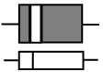
D3- D7 | Diodes |  |  | 1N4001 | No | Yes
ZENER DIODES
ZD1 | Zener |  |  | 12 volts | No | Yes | 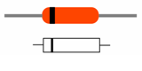
ZD2 | Zener |  |  | 6 volts | No | Yes
RESISTORS (No polarity)
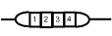
Colours |  |  |  |  | 1 | 2 | 3
R1, 8, 23 |  |  | 4.7 KΩ |  | Yellow | Purple | Red
R2, 12, 20 |  |  | 1 Ω |  | Brown | Black | Gold
R3, 14, 17 |  |  | 47 KΩ |  | Yellow | Purple | Orange
R4, 9, 10 |  |  | 1 KΩ |  | Brown | Black | Red
R5, 21 |  |  | 100 KΩ |  | Brown | Black | Yellow
R6, 18 |  |  | 220 KΩ |  | Red | Red | Yellow
R7 |  |  | 10 Ω |  | Brown | Black | Black
R11 |  |  | 10 MΩ |  | Brown | Black | Blue
R13, 15 |  |  | 22 KΩ |  | Red | Red | Orange
R16 |  |  | 10 KΩ choke |  | No colours, choke type resistor
R19, 22 |  |  | 10 KΩ |  | Brown | Black | Orange
R24 |  |  | 1MΩ |  | Brown | Black | Green
R25 |  |  | 330 Ω |  | Orange | Orange | Brown

COMPONENT | TYPE | VALUE | COLOUR CODE ID | POLARITY | POSITION
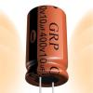
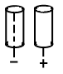
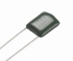
CAPACITORS

Polar (P) Type Non Polar (N) Type
 | Type | Value |  | Code
C1 | P | 100μF, 35 -50 volts |  | -
C2, C5, C9 | N | 0.1μF, 250 volts |  | 103
C3, C6, C8 | N | 0.47μF, 250 volts |  | 473
C4, C7 | N | 0.22μF, 50 volts |  | 223
Light emitting diode LED1 Can take any of terminal position on board

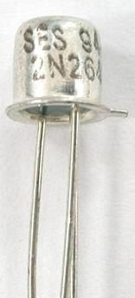
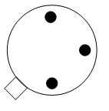
Projection on case of Unijunction (UJT) Transistor 2N2464 must match the projection in TR1 position on AVR Board

Projection on 2N2646 case

Projection on TR1 position on AVR board
IC component SC1 can take any position on the AVR board as long as the 6 pins fall into the SC1 position on board

8 pin IC LM 741must be correctly inserted on the IC1 position on AVR board. The chip mark on LM 741 must be at the position of U mark on the board. See drawing below.
